s

**Holy Trinity June 4, 2023**

**WELCOME & INSTRUCTION**

*Participants are invited to respond with the text in* **bold type.**

**GATHERING HYMN|** Holy, Holy, Holy, Lord God Almighty ELW 413

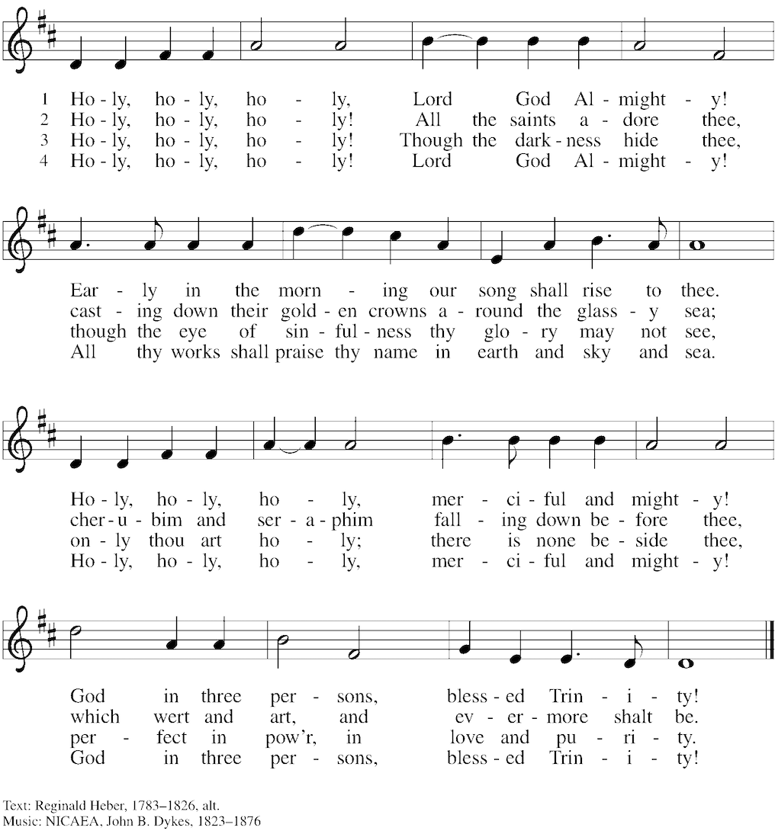

**GREETING**

The grace of our Lord Jesus Christ, the love of God, and the communion of the Holy Spirit be with you all. **And also with you.**

**PRAYER**

God of heaven and earth, before the foundation of the universe and the beginning of time you are the triune God: Author of creation, eternal Word of salvation, life-giving Spirit of wisdom. Guide us to all truth by your Spirit, that we may proclaim all that Christ has revealed and rejoice in the glory he shares with us. Glory and praise to you, Father, Son, and Holy Spirit, now and forever.

**Amen.**

### PSALM 8  1O Lord our Lord, how majestic is your name in all the earth!— 2**you whose glory is chanted above the heavens out of the mouths of infants and children;** **you have set up a fortress against your enemies, to silence the foe and avenger.**  3When I consider your heavens, the work of your fingers, the moon and the stars you have set in their courses, 4**what are mere mortals that you should be mindful of them,** **human beings that you should care for them?**   5Yet you have made them little less than divine; with glory and honor you crown them.  6**You have made them rule over the works of your hands;** **you have put all things under their feet:** 7all | flocks and cattle, even the wild beasts of the field, 8**the birds of the air, the fish of the sea,** **and whatever passes along the paths of the sea.**  9O Lord our Lord, how majestic is your name in all the earth!

### Holy Wisdom. Holy Word. Thanks be to God.

**GOSPEL ACCLAMATION|** ELW 175

### 

### GOSPEL READING| Matthew 28:16-20 *After his resurrection, Jesus summons his remaining disciples and commissions them to baptize and teach all nations in the name of the Father, Son, and Holy Spirit.*

### God is with you. And also with you. A Reading from the Holy Gospel according to Matthew. Glory to you, O Lord.

16Now the eleven disciples went to Galilee, to the mountain to which Jesus had directed them. 17When they saw him, they worshiped him; but some doubted. 18And Jesus came and said to them, “All authority in heaven and on earth has been given to me. 19Go therefore and make disciples of all nations, baptizing them in the name of the Father and of the Son and of the Holy Spirit, 20and teaching them to obey everything that I have commanded you. And remember, I am with you always, to the end of the age.”

The Gospel of the Lord. **Praise to you, O Christ.**

**MESSAGE|** *Rev. Jim Muratore, Pastor*

**BREAKOUT QUESTIONS**

* **What do you wonder about God? Jesus? Spirit?**
* **What are the things that truly mystify you?**

**NICENE CREED**

**We believe in one God,**

**the Father, the Almighty,**

**maker of heaven and earth,**

**of all that is, seen and unseen.**

**We believe in one Lord, Jesus Christ,**

**the only Son of God,**

**eternally begotten of the Father,**

**God from God, Light from Light,**

**true God from true God,**

**begotten, not made,**

**of one Being with the Father;**

**through him all things were made.**

**For us and for our salvation**

**he came down from heaven,**

**was incarnate of the Holy Spirit and the virgin Mary**

**and became truly human.**

**For our sake he was crucified under Pontius Pilate;**

**he suffered death and was buried.**

**On the third day he rose again**

**in accordance with the scriptures;**

**he ascended into heaven**

**and is seated at the right hand of the Father.**

**He will come again in glory to judge the living and the dead,**

**and his kingdom will have no end.**

**We believe in the Holy Spirit, the Lord, the giver of life,**

**who proceeds from the Father and the Son,\***

**who with the Father and the Son is worshiped and glorified,**

**who has spoken through the prophets.**

**We believe in one holy catholic and apostolic church.**

**We acknowledge one baptism for the forgiveness of sins.**

**We look for the resurrection of the dead,**

**and the life of the world to come. Amen.**

**PRAYERS OF INTERCESSION**

Trusting in God’s abundant mercy, let us offer our prayers for a world in need.

*A brief silence.*

Holy three, holy one, you call the church to make disciples of all nations. Encourage bishops, pastors, and deacons in their proclamation of the gospel and direct all the baptized into lives of humble service. God, in your mercy,

**hear our prayer.**

Holy three, holy one, you spoke creation into being and called it good. Protect lands and waters threatened by human misuse and sustain living creatures of every kind: wild animals, birds, fish, and every creeping thing. God, in your mercy,

**hear our prayer.**

Holy three, holy one, you have given humankind authority over the earth. Raise up leaders who listen earnestly, speak honestly, and govern thoughtfully. Heal divisions between nations, that we might agree with one another and live in peace. God, in your mercy,

**hear our prayer.**

Holy three, holy one, you promise to be with us always, to the end of the age. Surround those most in need of your healing presence: any who are lonely, all who are grieving, and those who are sick. We pray for all who seek your comfort. We pray for Bob and Jeanette, Rob and Scott, Ron and Beryl, Amanda, Buddy, Noah, Roman, Kristen, Pam, Jim, Quinn, Charles, Joe, Htet (Tet), Marie, Katie, Doug, the people of Ukraine, Russia, Sudan, and for all whom we name now.

God, in your mercy,

**hear our prayer.**

Holy three, holy one, you set the earth on its axis, and we experience the seasons. Strengthen those enduring challenges this summer: those who suffer in the heat, parents overwhelmed by childcare responsibilities, and children experiencing food insecurity outside of school. God, in your mercy,

**hear our prayer.**

Holy three, holy one, you give rest when our work is done. We give thanks for all the saints who now rest in you, confident in the promise of resurrection life in the age to come. God, in your mercy,

**hear our prayer.**

Receive our prayers and answer us, O God, in the name of Jesus Christ.

**Amen.**

**PEACE**

The peace of Christ be with you always. **And also with you.**

**OFFERING**

*Offering may be made electronically on the church’s website at www.churchontheavenuehampden.org. You can also sign up for automated giving. See Announcements at the end of the bulletin.*

**OFFERING PRAYER**

God of field and forest, sea and sky, you are the giver of all good things. **Sustain us with these gifts of your creation, and multiply your graciousness in us, that the world may be fed with your love, through Jesus Christ, our Savior and Lord. Amen.**

**COMMUNION**

*The assembly is invited to stand in body or spirit.*

**GREAT THANKSGIVING**



[P] The Lord is here



**[A] God’s Spir - it is with us**



[P] Let us lift up our hearts



**[A] We lift them to our God**



[P] Let us give thanks to the Lord our God



**[A] It is right to give our thanks and praise.**

It is indeed right, our duty and our joy, that we should at all times and in all places

give thanks and praise to you, almighty and merciful God.

You reveal your glory as the glory of the Father, the Son, and the Holy Spirit:

equal in majesty, undivided in splendor, one Lord, one God,

ever to be adored in your eternal glory.

And so, with all the choirs of angels,

with the church on earth and the hosts of heaven,

we praise your name and join their unending hymn:

**Holy, holy, Holy Lord,**

**God of power and might.**

**Heaven and earth are full of your glory.**

**Hosanna in the highest.**

**Blessed is the one who comes in the name of the Lord.**

**Hosanna in the highest. Hosanna in the highest.**

Holy God, holy and mighty, holy and immortal:

you we praise and glorify, you we worship and adore.

You formed the earth from chaos;

you encircled the globe with air;

you created fire for warmth and light;

you nourish the lands with water.

You molded us in your image,

and with mercy higher than the mountains,

with grace deeper than the seas,

you blessed the Israelites and cherished them as your own.

That also we, estranged and dying,

might be adopted to live in your Spirit,

you called to us through the life and death of Jesus.

In the night in which he was betrayed,

our Lord Jesus took bread, and gave thanks;

broke it, and gave it to his disciples, saying:

Take and eat; this is my body, given for you.

Do this for the remembrance of me.

Again, after supper, he took the cup, gave thanks,

and gave it for all to drink, saying:

This cup is the new covenant in my blood,

shed for you and for all people for the forgiveness of sin.

Do this for the remembrance of me.

Together as the body of Christ,

we proclaim the Lord’s death until he comes:

**Christ has died.**

**Christ is risen.**

**Christ will come again. Christ will come again.**

Holy God, holy and merciful one, holy and compassionate, send upon us and this meal your Holy Spirit, whose breath revives us for life, whose fire rouses us to love. Enfold in your arms all who share this holy food. Nurture in us the fruits of the Spirit, that we may be a living tree, sharing your bounty with all the world.

Through Christ, with Christ and in Christ, in the unity of the Holy Spirit, all glory and honor is yours Almighty God, forever and ever. **Amen. Amen. Amen. Amen.**

**THE LORD’S PRAYER**

**DISTRIBUTION OF HOLY COMMUNION**

*Communion is served by way of intinction. Come forward in a counter clockwise circle. Hand sanitizer is available at the altar for your use. A dab’ll do! Receive the bread in your hand and dip into the cup. The clay chalice is reserved for gluten free recipients. If you wish not to receive you are welcome to remain seated or come forward with crossed arms to receive a blessing. ALL are welcome to come and receive without exception.*

**PRAYER AFTER COMMUNION**

We thank you, generous God, for the refreshment we have received at your banquet table.

Send us now to spread your generosity into all the world, through the one who is our dearest treasure, Jesus Christ, our Savior and Lord.

**Amen.**

**ANNOUNCEMENTS**

**New Member Sunday, NEXT WEEK!** Join us as we receive several of the newest members of our community as formal members of the congregation. If you would like to be included in the reception of new members, you can see Pastor Jim after the service today.

**HAMPDEN FAMILY CENTER| Hats Off to Hampden**  
Thursday, June 8, 2023, 7–10 p.m. Union Craft Brewing

Tickets $75   
Reserved Tables of 8 - $600

Get Tickets at [hampdenfamilycenter.org](http://hampdenfamilycenter.org/)

**HONFEST| June 10 &11th**

Be sure to come out for the annual street festival here on the Avenue! Both days, the church will be open for viewing and for restroom use. This is the 30th anniversary of the event so it promises to be a special occasion! We will likely have the thrift shop open for both days of the event, if you would like to help manage the space and hospitality for all or part of the weekend you can talk with Pastor Jim.

**COME AND SEE!!!** So much is going on here at St. Luke’s Church on the Avenue, please visit our website to view the calendar and explore links to activities happening every day! Visit us at [www.churchontheavenuehampden.org](http://www.churchontheavenuehampden.org) or by scanning the QR Code below.

**Thank you** for your continued generosity and for sustaining our ministry during this strange and difficult time! You can provide offering or make a special gift at anytime through the church’s giving portal. Links can be found in the e-newsletter and on the church website at <http://www.churchontheavenuehampden.org.> or by scanning the QR Code below.

**BENEDICTION**

God is with you! **And also with you!**

The God who calls across the cosmos

and speaks in the smallest seed:

Father, ☩ Son, and Holy Spirit, bless, keep, and sustain you

now and to the end of the age.

**Amen.**

**SENDING HYMN|** Holy God, We Praise Your Name  ELW 414

**DISMISSAL**

Go in peace. Serve the Lord. **Thanks be to God!**